The object of this Spike Order customization is to place a sales order on hold if the order qty is equal to or greater than 50% of the re-order point for any line on the sales order.

Items that are setup with a Replenishment Method of Reorder Point will have values populated in the Reorder Point (Build Point if it is an assembly) and Preferred Stock Levels at the location level.

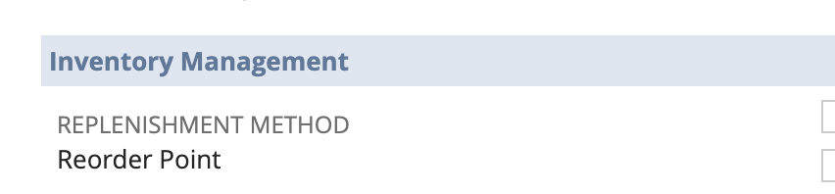

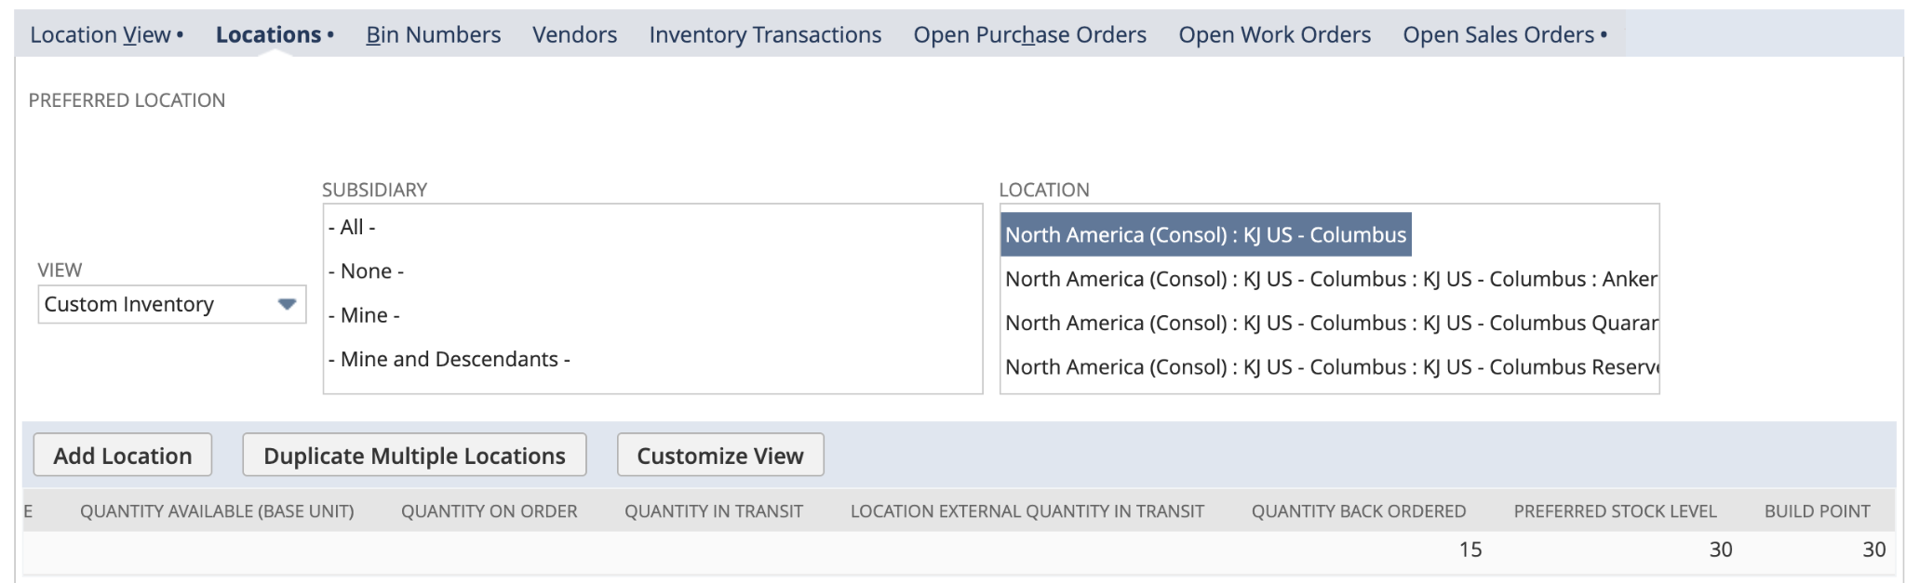

The logic for the customization is as follows:

* If an order is placed for an item that has a Replenishment Method of Reorder point, validate the qty ordered on the sales order lines.
* If the qty ordered on ANY sales order line for the order is equal to or greater than 50% of the Reorder/Build Point then update the sales order status to Pending Approval and check a custom field at the header titled Spike Order.
* We will have a custom field at the line level of the sales order that will populate with the 49% of the reorder point for that item/location. This can be used to help easily identify the problematic line items on orders with many lines.

Location will be determined at the header level of the sales order.

This will need to happen for all orders regardless of how they are created in the system: that are imported from the web, imported via .csv, manually entered, etc.

We would then create a saved search to identify orders pending approval that are marked as a Spike Order